Sportifry

Software Development Plan

Version <3.0>

Revision History

| **Date** | **Version** | **Description** | **Author** |
| --- | --- | --- | --- |
| 22/10/2021 | 1.0 | Briefly edit the document | Trần Vĩnh Phát |
| 22/11/2021 | 2.0 | Briefly edit the document | Trần Vĩnh Phát |
| 22/12/2021 | 3.0 | Briefly edit the document | Trần Vĩnh Phát |
|  |  |  |  |

Table of Contents

**Introduction** **4**

**Project Overview** **4**

*Project Purpose, Scope, and Objectives* *4*

*Assumptions and Constraints* *4*

*Project Deliverables* *4*

**Project Organization** **4**

*Organizational Structure* *4*

*Roles and Responsibilities* *5*

**Management Process** **5**

*Project Estimates* *5*

*Project Plan* *5*

Phase and Iteration Plan 5

Releases 5

Project Schedule 5

*Project Monitoring and Control* *5*

Reporting 5

Risk Management 6

Configuration Management 6

Software Development Plan

# 

# Introduction

Currently, music is one of the optimal and indispensable sources of human entertainment. In particular, music can also have a great impact on the process of human development. Without music, the world would be very dull. Music is extremely important for human happiness. It helps dispel suffering, bring joy, youth, and life. Enjoying favorite songs helps people relax and have a lot of interesting experiences. That's why our need to listen to music is increasing. For many people, music is an indispensable thing in our lives. all activities including study and work. Listening to music helps stimulate the brain to develop comprehensively, creatively, reduce stress, increase work productivity. Therefore, we decided to create a website that provides music services, but not just like the existing websites, the website we aim to be suitable for people who take music as inspiration for their work.

# Project Overview

## Project Purpose, Scope, and Objectives

* purpose: The website serves music listening utilities and supports working directly on the site and at the same time relieves users' frustration when encountering unexpected problems.
* scope: 6 years old and up.
* object: serving everyone, especially office workers and students.

## Assumptions and Constraints

* Project has a fixed schedule of 12 weeks
* Zero-budget project
* Project has 5 people, there will be no more people added during the project
* Beta version is expected to be completed in week 10
* There is 1 fixed meeting every week

## Project Deliverables

* Demo version: 3/12/2021
* Beta 1 version: 12/12/2021
* Release version: 1/1/2022

# Project Organization

## Organizational Structure

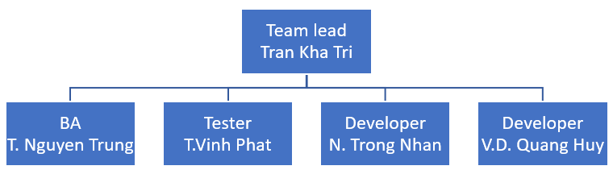

## Roles and Responsibilities

| **Student ID** | **Name** | **Role** | **Tasks** |
| --- | --- | --- | --- |
| 19127597 | Tran Kha Tri | PM | Write reports, documents |
| 19127607 | Tran Nguyen Trung | BA | Functional analysis |
| 19127426 | Vu Duc Quang Huy | Dev | Coding |
| 19127491 | Nguyen Trong Nhan | Dev | Coding |
| 19127057 | Tran Vinh Phat | Tester | Test function, UI design |

# Management Process

## Project Estimates

* Sprint 1: 16/10/2021
* Sprint 2: 30/10/2021
* Sprint 3: 13/11/2021
* Sprint 4: 27/11/2021
* Sprint 5: 11/12/2021
* Sprint 6: 25/12/2021
* Demo version: 3/12/2021
* Beta 1 version: 12/12/2021
* Release version: 1/1/2022

## Project Plan

### Phase and Iteration Plan

See the Gantt-chart file:[Gantt-Chart](https://docs.google.com/spreadsheets/d/1wniqpdZMgv-G5K-obrXIGSLziXzGZ7J4nne8h1kRGfU/edit?usp=drive_web&ouid=114264235216595126302)

### Releases

* Demo version: 3/12/2021
* Beta 1 version: 12/12/2021
* Release version: 1/1/2022

### Project Schedule

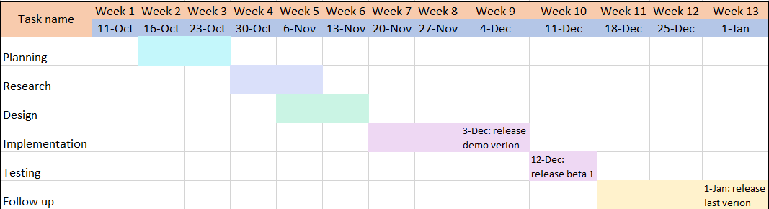

## Project Monitoring and Control

### Reporting

* Week 1: [Week 1 Report](https://docs.google.com/document/d/11neRvngeJ-pPBd6YT7mPn1AAPxCQUE-XPhS99UMu8BY/edit?usp=sharing)
* Week 2: [Week 2 Report](https://docs.google.com/document/d/14LTeApT6VbmBsQG9m6L_32gczwWaijxtT8Fo4Iy7gbU/edit?usp=sharing)
* Week 3: [Week 3 Report](https://docs.google.com/document/d/10D0cKq6q1-KinYJDJ98IKwXmB9tdlzCKsQZBmtqcAp4/edit?usp=sharing)
* Week 4:[Week 4 Report](https://docs.google.com/document/d/1mQiKlL5ATMEggcUsJ5L3NNb5R6n36sjPryaxQKLLtYE/edit?usp=sharing)
* Week 5: [Week 5 Report](https://docs.google.com/document/d/11A8nN-E9zpBE1CJ-sCYATtDiIjONGMJIoIjL4YJsMdY/edit?usp=sharing)
* Week 6:[Week 6 Report](https://docs.google.com/document/d/1kGFZW3mpS9RLTqjArmi2TsCmIZlcATvsqA012Sj94-I/edit?usp=sharing)
* Week 7: [Week 7 Report](https://docs.google.com/document/d/1AJnqvMKBEp4-kWnjNhUDq4gUTMxSqWH58DP09xXVmXs/edit?usp=sharing)
* Week 8: [Week 8 Report](https://docs.google.com/document/d/1V0OgDo5tYSIVt_9t8QRdEQAaBfQIBwaS9EZITZt3XyQ/edit?usp=sharing)
* Week 9: [Week 9 Report](https://docs.google.com/document/d/1-7xwbJvhYg2Dnl-tPTAgOFhHq9B0jEmj7epk1pAGTPM/edit?usp=sharing)
* Week 10: [Week 10 Report](https://docs.google.com/document/d/1qbzNpF5B3Z9tOl9w2wSGa38L8E2DPYJAuB0QRKrPamI/edit?usp=sharing)
* Week 11: [Week 11 Report](https://docs.google.com/document/d/1_phBfVzAH_PmTO7t54tcMTcbwDMLZByYY-h5prAV8QY/edit?usp=sharing)

### Risk Management

| Risk ID | Risk Description | Probability | Impact | Priority | Mitigation Strategy or Contingency Plan |
| --- | --- | --- | --- | --- | --- |
| 01 | Team member problems | Sometimes | Team don’t have a good performance | Low | Discuss with the group to find a solution |
| 02 | Technique is too difficult | Sometimes | Inability to learn in depth | Medium | Discuss with the group to find a solution or will ignore and find another solution |
| 03 | Functions that need to be changed | Sometimes | Need to change if my team want to work well | High | Need to discuss with team members to come up with an appropriate change strategy |

### Configuration Management

* Google Drive for storing and sharing documents: <https://bitly.com.vn/zzfska>
* Github for managing source code and files: <https://github.com/chopcolate/sportifry.github.io>
* Slack for information exchange:<https://bitly.com.vn/el3pq8>